Omega-Genesis
Compressed Odd Dynamics and a Structural Reduction Framework
for the Collatz Conjecture
Timothy J. Dillon
Integrated Master Manuscript — Version 9
Main manuscript + computational appendix + claim-status register

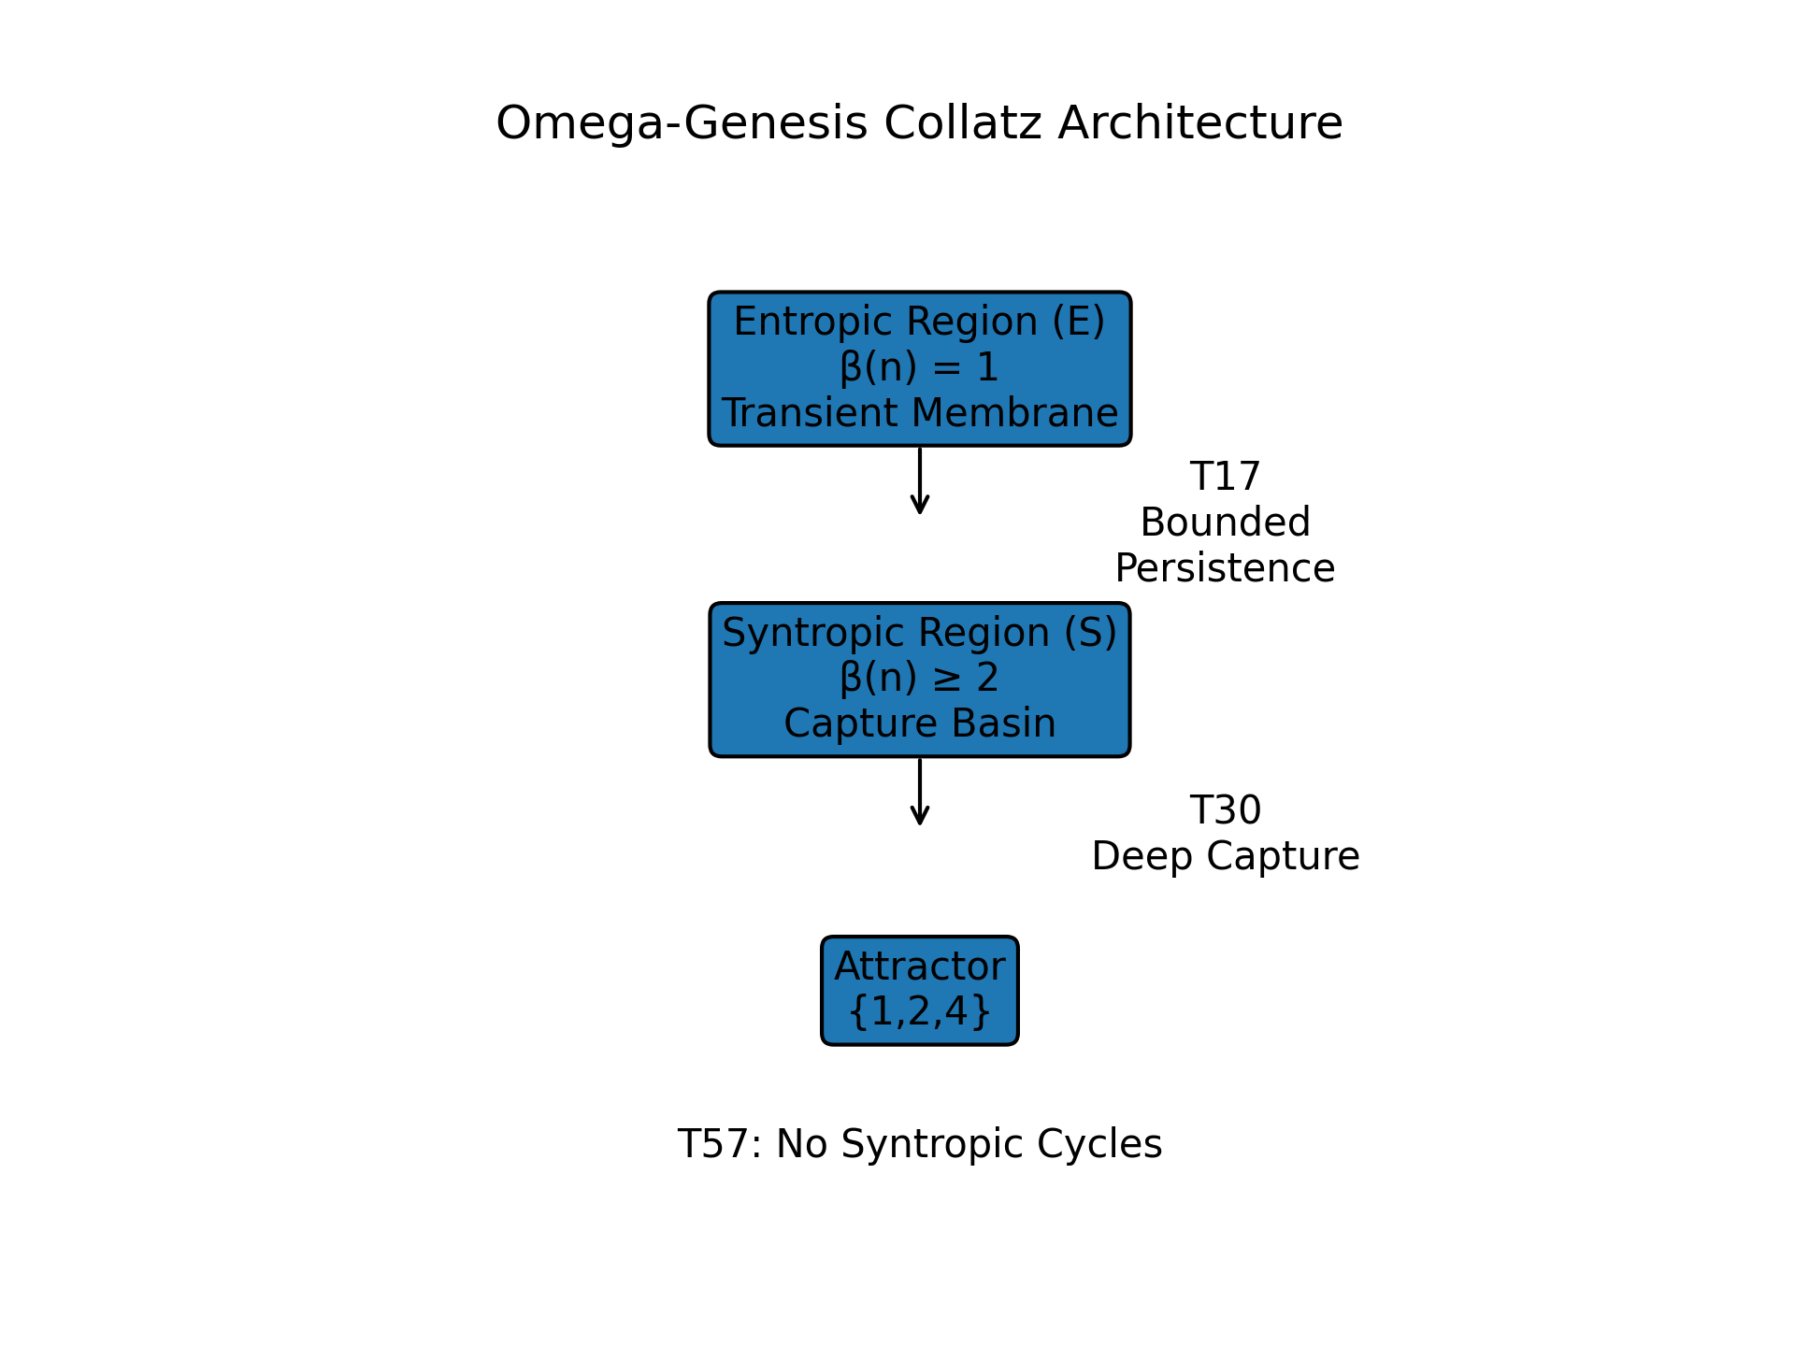
Figure 1. Omega-Genesis architecture: entropic transient membrane E, syntropic capture basin S, and trivial attractor Ω = {1,2,4}.

Abstract
We study the compressed odd Collatz map U(n) = (3n + 1) / 2^β(n), where β(n) = v₂(3n + 1), and present Omega-Genesis as an integrated structural reduction framework for the Collatz conjecture. The manuscript is organized around exact entropic persistence, deterministic deep syntropic contraction, a corrected segment-model exclusion principle, and a four-family endgame architecture for the remaining obstruction. These results support a theorem spine in which deep-block words are excluded unless entropic expansion drives them toward a segment-critical boundary, strongly light words are reduced to bounded persistence or fragmented return structures, and the unresolved obstruction is compressed into a bounded residual arithmetic core. The computational appendix records exact bounded finite-core verification runs with zero survivors in the tested ranges. This revision is intentionally referee-facing: it sharpens the structural reduction theorem, clarifies the four-family architecture, and makes the closure burden explicit while preserving claim discipline.
1. Introduction
The Collatz problem asks whether repeated iteration of the map T(n) = n/2 for even n and T(n) = 3n + 1 for odd n eventually reaches 1 for every positive integer n. Despite its elementary form, the problem has resisted proof for decades.
This manuscript approaches the problem through the compressed odd map U(n) = (3n + 1) / 2^β(n), which records the odd-to-odd dynamics directly. The guiding idea is not to attack arbitrary trajectories all at once, but to organize the dynamics into regions with distinct structural behavior and to prove exact reduction steps that force all unresolved behavior into a bounded arithmetic frontier.
Omega-Genesis is presented here as a structural reduction framework for the Collatz conjecture. The manuscript separates exact theorems, reduction theorems, bounded computational evidence, and residual closure targets so that each layer can be audited independently.
2. Claim Status and Theorem Register
Category | Current status
Proved theorems | Exact entropic persistence; deep syntropic block contraction; corrected segment-model exclusion; uniform deep-block bounds; light-regime counting lemma.
Reduction theorems | Deep-block exclusion under controlled entropic expansion; reduction to shallow words and deep residuals; light-regime reduction and fragmentation-to-residue reduction; finite exact shallow enumeration; finite-core verification principle; pure syntropic cycle reduction in finite-candidate form.
Bounded computational evidence | Zero survivors in tested bounded cores; exact bounded shallow residual-family enumeration in tested ranges; empirical support for near-critical sparsity, long-block contraction, first-crossing capture behavior, and outlier survival collapse.
Current closure targets | Universal emptiness of the pure syntropic candidate family; universal elimination of the segment-critical deep remainder; universal boundedness and emptiness of the shallow residual family; universal emptiness of the near-critical core.
Interpretive summary. The present work proves a structural reduction spine for the compressed odd Collatz dynamics, reduces the unresolved obstruction to a bounded residual arithmetic core, and reports zero surviving candidates in tested bounded cores. The remaining closure burden is concentrated in universal elimination of the residual families S, R, H, and C, equivalently the universal emptiness of the bounded residual core.
3. Theorem Spine
The Omega-Genesis program is built on a theorem spine consisting of exact identities, deterministic contraction results, and structural exclusion principles for the compressed odd Collatz dynamics.
Throughout, we work with the compressed odd map U(n) = (3n + 1) / 2^β(n), where β(n) = v₂(3n + 1), defined on positive odd integers. We distinguish the entropic region E = {β = 1} and the syntropic region S = {β ≥ 2}.
Theorem 3.0 (Structural Reduction Theorem — program statement).
Assume: (i) entropic persistence in E = {β = 1} is exactly controlled; (ii) sufficiently deep syntropic entry induces contraction-biased dynamics; (iii) no pure syntropic periodic orbit survives universal elimination; and (iv) the remaining near-critical trajectories reduce to finitely many residual arithmetic families. Then the global Collatz problem reduces to a finite arithmetic verification problem, and all surviving trajectories must converge to Ω = {1,2,4}.
Interpretation. The purpose of Omega-Genesis is not to force one-step monotonic descent on all odd states. Rather, it reduces the infinite odd-state search to a finite structural elimination problem through exact persistence, capture-biased contraction, cycle reduction, and finite-core verification.
Theorem 3.1 (Exact entropic persistence).
For every positive odd integer n, the number of consecutive compressed odd steps spent in the entropic region is L_E(n) = v₂(n + 1) - 1.
Proof sketch. If β(n) = 1, then U(n) = (3n + 1) / 2 and U(n) + 1 = 3(n + 1) / 2. Since 3 is odd, v2(U(n) + 1) = v₂(n + 1) - 1. Thus each entropic step lowers v₂(n + 1) by exactly one, and the number of consecutive entropic steps is exactly v₂(n + 1) - 1.
Theorem 3.2 (Deep syntropic block contraction).
If β(n_i) ≥ X ≥ 2 on a block of length k, then n_k ≤ (3 / 2^X)^k n_0 + 1 / (2^X - 3).
Proof sketch. For each step in the block, n_{j+1} = (3n_j + 1) / 2^{β(n_j)} ≤ (3 / 2^X)n_j + 1 / 2^X. Setting r = 3 / 2^X and s = 1 / 2^X gives n_{j+1} ≤ r n_j + s. Iterating yields n_k ≤ r^k n_0 + s(1 - r^k)/(1 - r) ≤ (3 / 2^X)^k n_0 + 1/(2^X - 3).
Segment-model exclusion theorem.
For a mixed segment word with canonical affine data A_seg and C_ref, if A_seg < 1 and C_ref < 1 - A_seg, then the word cannot be realized by a positive odd periodic orbit.
Proof sketch. If a positive odd periodic realization existed, the segment model would imply n_0 ≤ A_seg n_0 + C_ref. Rearranging gives (1 - A_seg)n_0 ≤ C_ref. Since n_0 ≥ 1, this forces 1 - A_seg ≤ C_ref, contradicting C_ref < 1 - A_seg.
Pure syntropic cycle reduction (T57, reduction form).
Any pure syntropic cycle must satisfy the exact cycle equation n_0(2^B - 3^m) = Σ_{r=0}^{m-1} 3^{m-1-r} 2^{S_r}, where B = Σβᵢ and S_r = Σ_{j<r}β_j. For fixed m, pure syntropic cycles are therefore reduced to a finite arithmetic candidate family.
Proof sketch. This is a reduction theorem, not yet a universal exclusion theorem. The remaining proof burden is to show that the resulting finite arithmetic candidate family is empty.
4. Deep-Block Exclusion and Quantitative Near-Critical Reduction
Mixed words containing a syntropic block of depth at least 3 are excluded whenever the surrounding entropic expansion is not large enough to push the segment-model multiplier back toward the critical boundary.
Uniform deep-block bounds give a_S(X,s) ≤ (3/8)^s and b_S(X,s) ≤ 1/5 for X ≥ 3. Writing A_seg = (3/2)^{ℓ_tot} Λ, one obtains an explicit entropic threshold: if ℓ_tot ≤ log(ρ/Λ) / log(3/2), then A_seg ≤ ρ.
Therefore, if a mixed word contains a depth-3-or-deeper block and also satisfies C_ref < 1 - ρ, then it is excluded. Any unresolved deep word must lie in a segment-critical deep residual family defined by excessive entropic compensation or excessive additive slack.
5. Reduction to the Shallow Residual Family
Every non-excluded mixed word is either deep, in which case it lies in the segment-critical deep residual family, or shallow, meaning every syntropic block has threshold exactly 2. This makes the shallow X = 2 regime the principal remaining residual target.
Once explicit deep-family bounds are available, the entire unresolved obstruction passes to the shallow residual family.
6. Light-Regime Counting and Fragmentation Reduction
For a block of length m with total valuation B, the exact block multiplier is A(w) = 3^m / 2^B. Strong lightness means B ≤ m log₂ 3 - δ.
A counting lemma shows that any such block must contain at least (2 - log₂ 3)m + δ indices with βᵢ = 1, so strong lightness forces an abnormally high density of entropic steps.
If these β = 1 steps do not accumulate into a long entropic run, they must fragment into many short runs, which forces repeated returns through β ≥ 2 states and therefore repeated residue compatibility constraints. Thus strongly light behavior is reduced to bounded entropic persistence, fragmented return structures, or a bounded exceptional arithmetic family.
7. Exact Rational Enumeration of the Theorem-Relevant Shallow Family
Under explicit bounds on syntropic block count, shallow block lengths, and entropic run lengths, the shallow residual family becomes finite and exactly enumerable. All decisions are made using exact rational arithmetic.
A shallow template is theorem-relevant if A_seg < 1 and C_ref ≥ 1 - A_seg. Each such template is assigned a residual score Score = C_ref - (1 - A_seg) and a critical-line deviation Δ = B - m log₂ 3.
Figure 6.1. Deviation geometry under a Geometric(1/2) valuation model (illustrative).
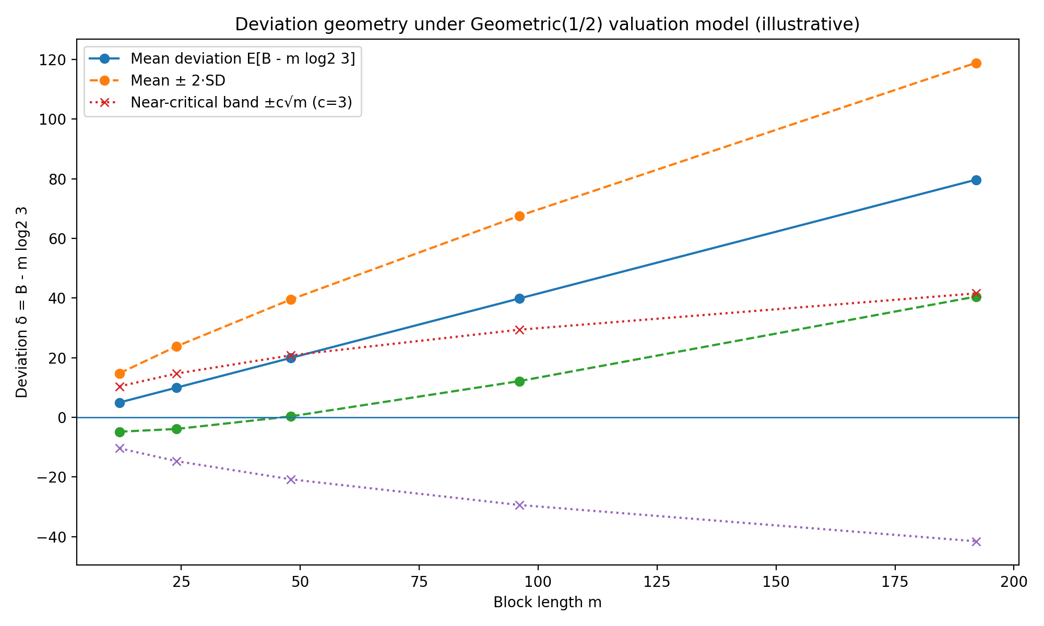
This plot visualizes the near-critical strip width ±c√m relative to the typical deviation δ = B − m log₂3 under the renewal-model heuristic. It is included as an interpretive aid, not as a proof statement.
Figure 6.2. Finite-core size versus deviation bound in representative verification runs.
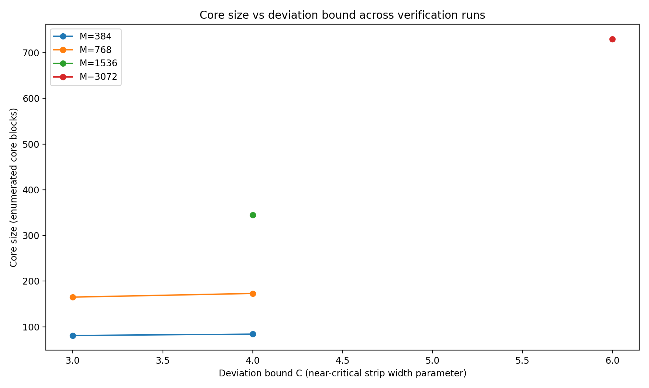
Each point corresponds to a bounded-core parameter set (modulus M, entropic-prefix cap L, syntropic-tail cap Q, deviation bound C) used in the finite-core protocol. The y-axis counts enumerated core blocks; all runs reported zero surviving candidates under the implemented filter pipeline.
This finite theorem-relevant shallow residual family is the bounded near-critical arithmetic core that remains after the structural reductions.
8. Packet / S-Unit and Residue Elimination of Theorem-Relevant Shallow Residuals
Each theorem-relevant shallow template determines an exact cycle equation and a normalized packet equation whose terms lie in the multiplicative group generated by 2 and 3.
The finite residual family is filtered by low-order packet exclusions, residue-admissibility tests modulo small primes and prime powers, and exact finite verification of positivity, integrality, oddness, and forward valuation compatibility.
At this stage the remaining obstruction is no longer an infinite dynamical family, but a finite arithmetic verification problem.
9. Integrated Computational Appendix
This appendix records bounded finite-core verification runs performed with the Omega-Genesis finite-core protocol. These computations do not constitute a universal proof of Collatz closure. Their role is limited to testing whether the bounded near-critical core defined by the current reduction framework contains any surviving candidates within enumerated parameter ranges.
For each bounded-core run, the protocol applied the following implemented filters in order: exact cycle-equation divisibility; positive odd candidate extraction; packet/S-unit low-order exclusions; forward valuation verification; and refined mixed-SCC persistence checks.
Table A1. Tested parameter ranges and bounded finite-core results.
M | L | Q | C | Core | Survivors | Div | Odd
384 | 8 | 10 | 3.0 | 81 | 0 | 21 | 60
768 | 8 | 10 | 4.0 | 173 | 0 | 53 | 120
1536 | 8 | 10 | 4.0 | 345 | 0 | 105 | 240
1536 | 12 | 14 | 6.0 | 365 | 0 | 125 | 240
3072 | 8 | 10 | 4.0 | 687 | 0 | 207 | 480
3072 | 12 | 14 | 6.0 | 730 | 0 | 250 | 480
Across all tested bounded-core ranges, the number of survivors was zero. In every recorded run, all enumerated candidates were eliminated at the first exact-arithmetic stage: either exact cycle-equation divisibility failed, or the extracted arithmetic candidate was not a positive odd integer.
The strongest bounded stress run used modulus 3072 with L = 12, Q = 14, and C = 6.0. It produced 730 core blocks and 0 survivors, with 250 divisibility eliminations and 480 not-positive-odd eliminations.
These are bounded computational propositions only. Their significance is to support the finite-core elimination program by showing that increasingly larger tested bounded cores remain empty under the implemented protocol.
References
[1] Lagarias, Jeffrey C. The 3x+1 problem and its generalizations. The American Mathematical Monthly 92(1):3-23, 1985.
[2] Lagarias, Jeffrey C. The 3x+1 Problem: An Overview. arXiv:2111.02635, 2021.
[3] Tao, Terence. Almost all orbits of the Collatz map attain almost bounded values. Forum of Mathematics, Pi 10:e12, 2022. Preprint arXiv:1909.03562.
[4] Evertse, J.-H., Schlickewei, H. P., and Schmidt, W. M. Linear equations in variables which lie in a multiplicative group. Annals of Mathematics 155(3):807-836, 2002.
[5] Baker, Alan. Classical lower bounds for linear forms in logarithms. Used here only as background for a Baker-type front-end.
[6] Applegate, David and Lagarias, Jeffrey C. The 3x+1 Semigroup. arXiv:math/0411140, 2005.

10. Final Reduction Architecture
This chapter consolidates the Omega-Genesis endgame into a single referee-facing structural framework. The earlier sections establish the theorem spine — exact entropic persistence, deep syntropic block contraction, corrected segment-model exclusion, and bounded finite-core verification. The present chapter states the four residual families, the structural reduction theorem, the conditional closure theorem, and the exact burden remaining for universal closure.
10.1 The four residual families
The unresolved obstruction is partitioned into four residual families: S (pure syntropic), R (segment-critical deep remainder), H (shallow residual), and C (near-critical core). Every hypothetical non-convergent odd orbit must lie in at least one of these four families.
10.2 Unified architecture diagram
ALL ODD ORBITS
|
v
Exact theorem spine applies first
entropic persistence - syntropic contraction - segment-model exclusion
|
v
If the orbit does not reach 1, apply the final classification
|
v
FOUR RESIDUAL FAMILIES TO ELIMINATE
S = Pure Syntropic
R = Segment-Critical Deep
H = Shallow Residual
C = Near-Critical Core
|
v
Target closure condition: S = R = H = C = ∅
|
v
Then no non-convergent odd orbit exists
|
v
Every odd orbit reaches 1 under U
|
v
Every positive integer reaches {1,2,4} under T
10.3 Structural Reduction Theorem
Theorem 10.3 (Omega-Genesis Structural Reduction Theorem). Let U(n) = (3n + 1) / 2^β(n) act on positive odd integers. Assume exact control of entropic persistence in E = {β = 1}, contraction-biased dynamics in sufficiently deep syntropic states S = {β ≥ 2}, exclusion of pure syntropic cycles in finite-candidate form, and reduction of the remaining near-critical trajectories to finitely many residual arithmetic families. Then the global Collatz problem reduces to a finite arithmetic verification problem, and universal convergence follows once the four residual families S, R, H, and C are shown to be empty.
10.4 Four residual families and closure posture
Pure syntropic family S. Eventually deep-good, uniformly negative long-block drift. Closure route: strict descent plus lower-bound contradiction and exclusion of forbidden deep recurrence.
Segment-critical deep remainder R. Eventually deep-good with drift in a near-critical nonpositive band but without bounded near-critical confinement. Closure route: residue localization plus no zero-drift or neutral deep cycles.
Shallow residual family H. Infinitely many shallow returns, each excursion finite. Closure route: exact entropic persistence plus domination of shallow inflation by cumulative deep contraction.
Near-critical core C. Bounded medium-depth valuation band, tiny drift, and infinite recurrence in a finite residue core. Closure route: finite residue-graph construction, cycle enumeration, and exact elimination certificates.
10.5 Conditional final closure theorem
Theorem 10.5 (Conditional final closure theorem). Assume: (i) every non-convergent odd orbit under U belongs to at least one of the residual families S, R, H, and C; and (ii) S = R = H = C = ∅. Then every odd orbit under U reaches 1. Consequently every positive integer reaches the classical Collatz cycle {1,2,4}.
Proof. If some odd orbit never reached 1, then by the classification theorem it would belong to at least one of the four residual families. If all four families are empty, this is impossible. Therefore no non-convergent odd orbit exists, every odd orbit under U reaches 1, and the classical Collatz conclusion follows.
10.6 Program-level summary
Omega-Genesis is therefore best read as a strengthened structural reduction framework with an explicit endgame ladder. The manuscript proves the theorem spine, reduces the unresolved obstruction to four sharply defined residual families, supplies bounded computational evidence with zero survivors in tested cores, and packages the remaining closure burden into a finite arithmetic elimination problem.

